Creating and deploying lambda function

In this module we will write lambda function

Deploying lambda function

Testing ,monitoring and trouble shooting

Lambda function overview

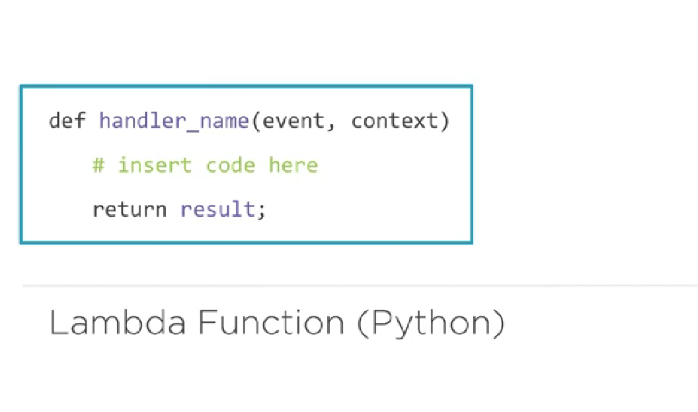

Event handler is the first statement in the fuction

It has 2 parameters

Event—it provides input values to the handler

Context—it provided run time values to the handler

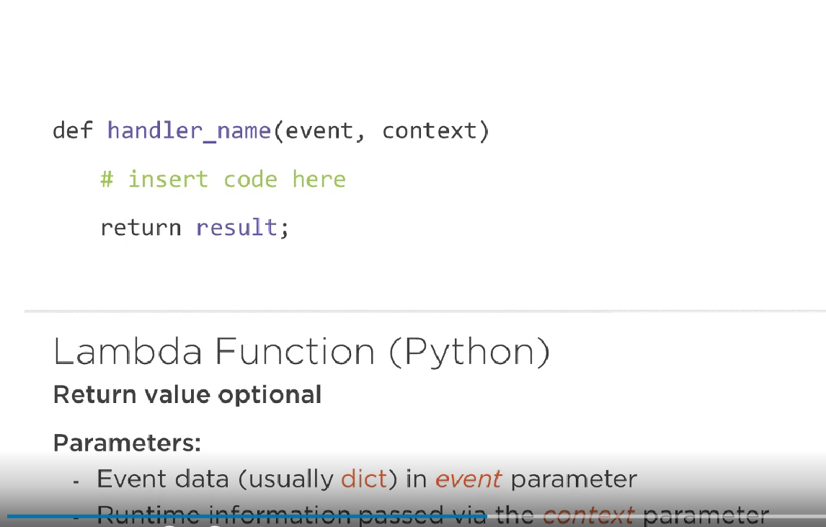

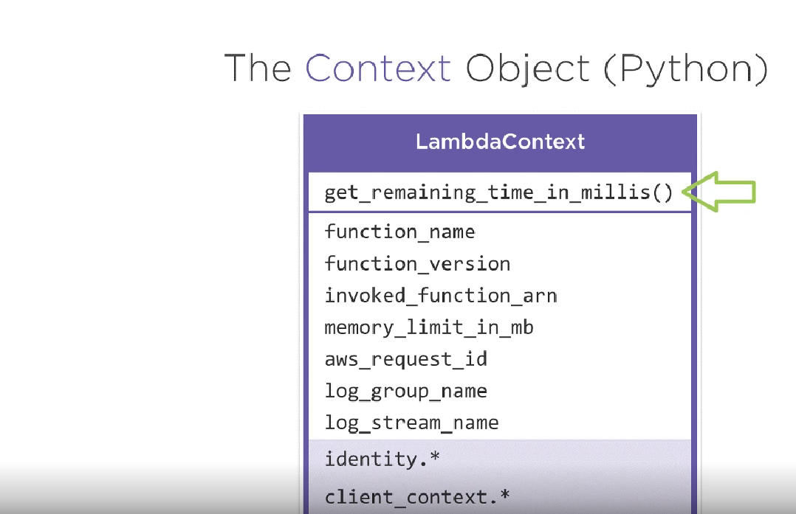

Creating a new lambda function

Three ways to create lambda function

1.from scratch

2.using blue print

3.serverless application repository

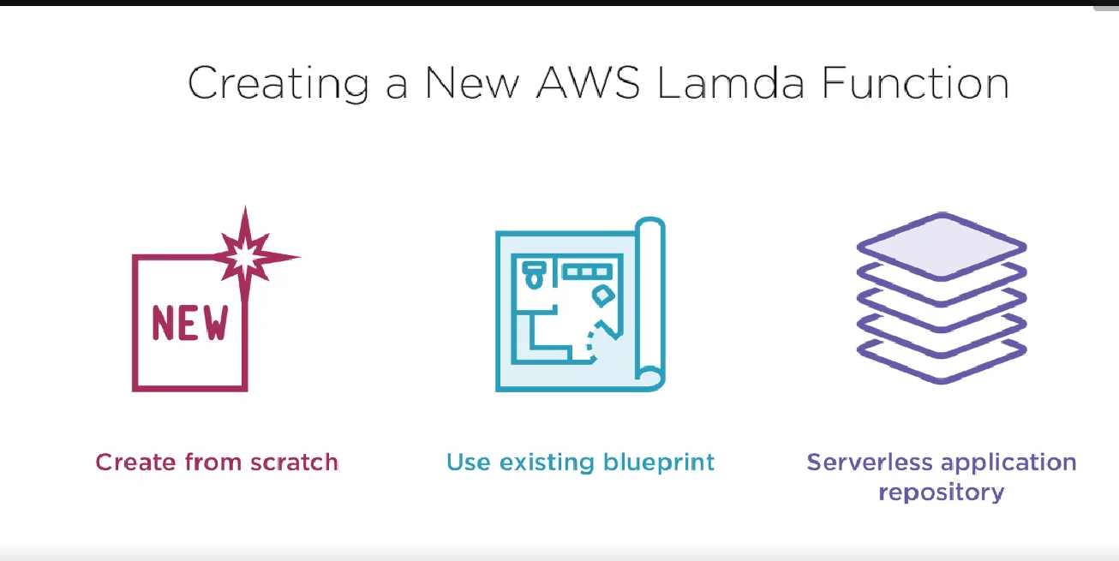

Creating dynamodb table

Provide values to name and primary key

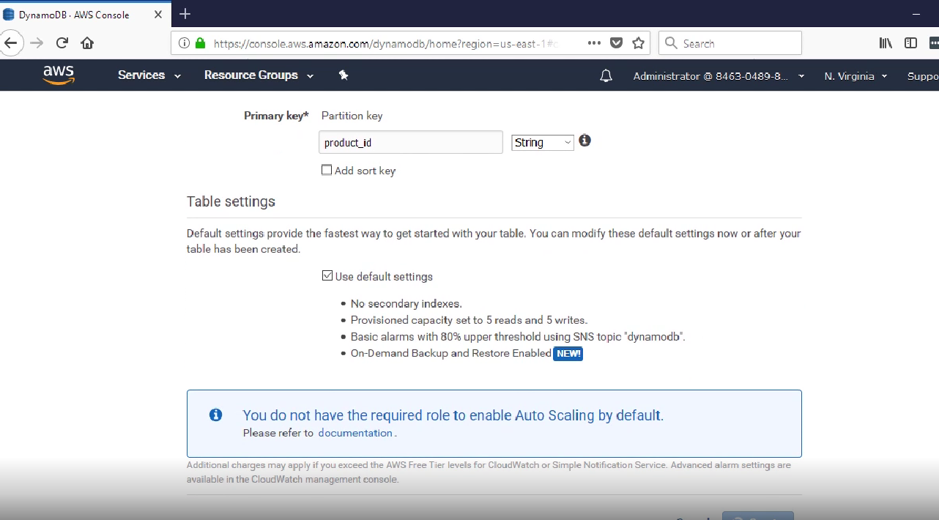

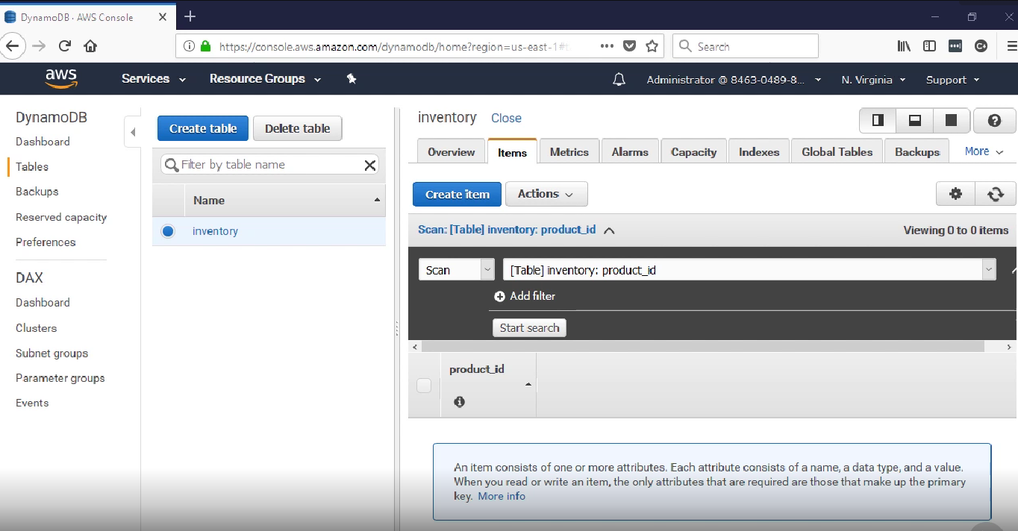

Creating new lambda function

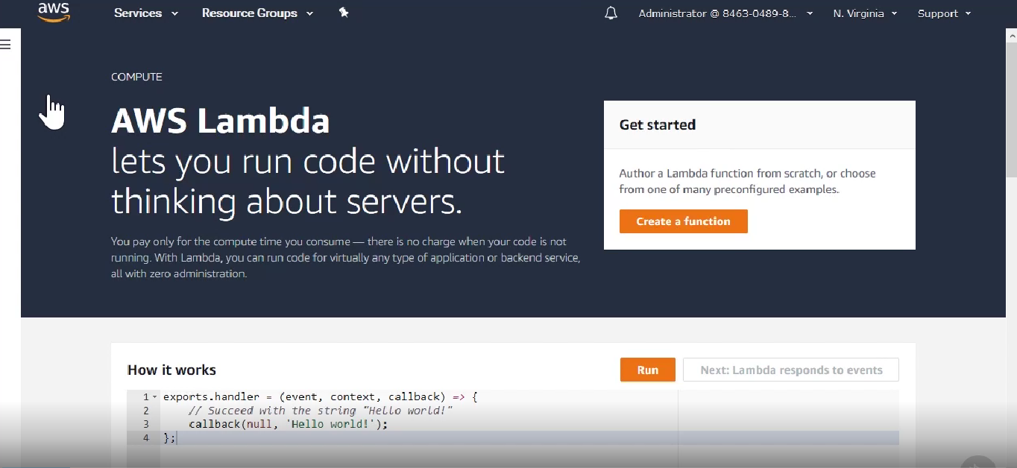

We need to give function and runtime value

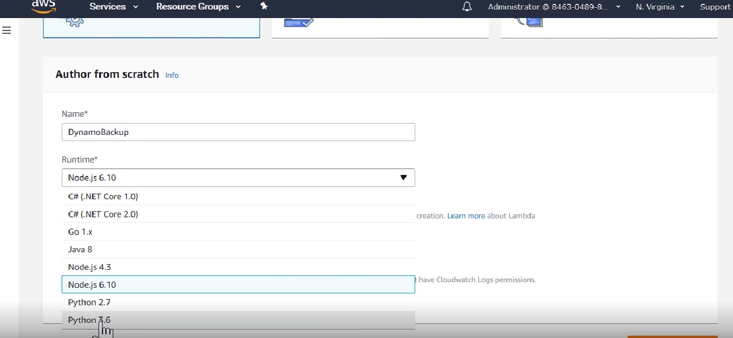

We have to create role for lambda

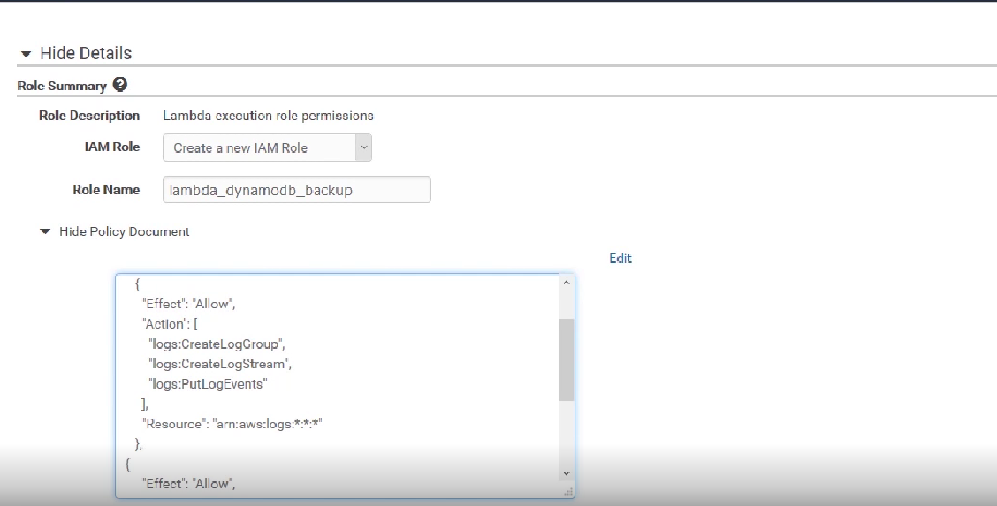

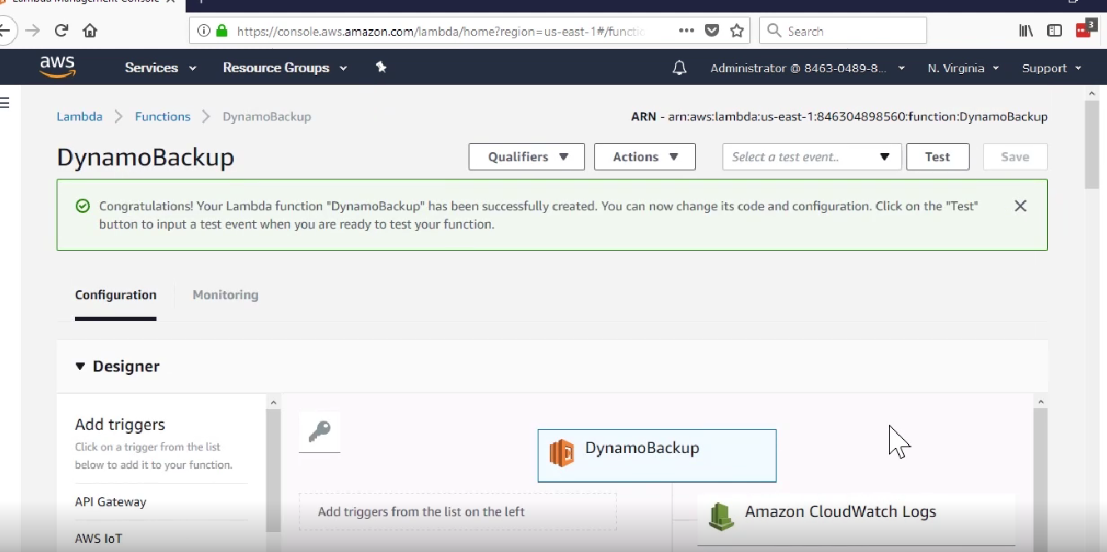

In code we will mention bote3 and boto3 client for dynamaodb

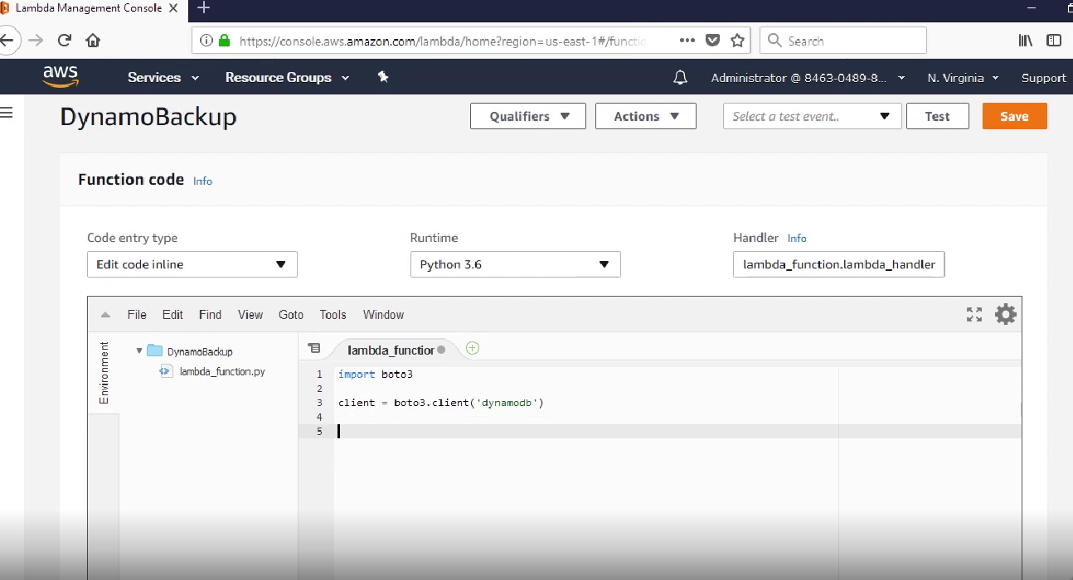

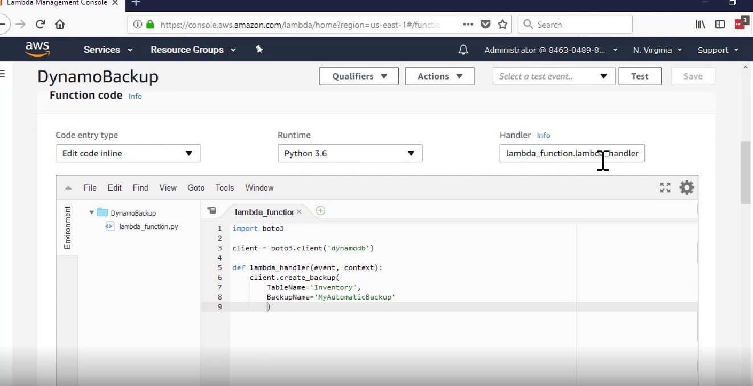

After code written we have to give event name to create event

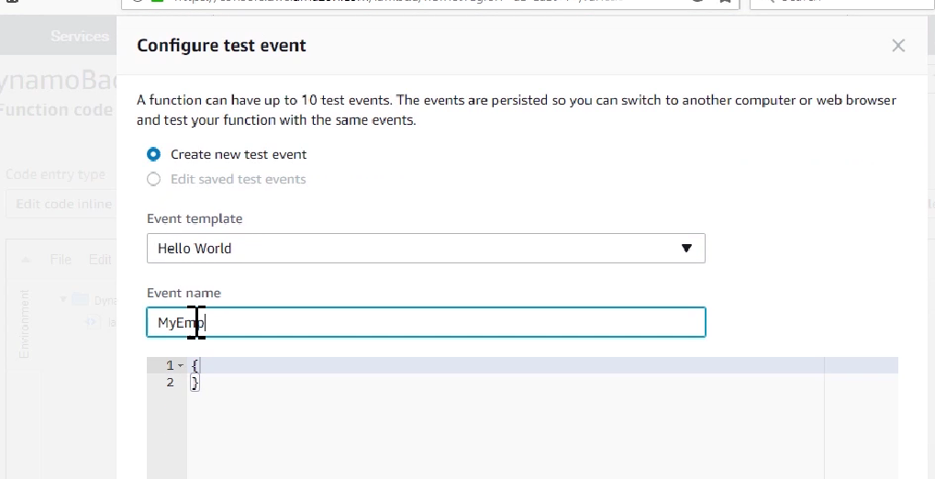

We can see lambda backup table in below screen shot

